

Marmara University
Faculty of Engineering
PHYS 1103.18
PHYSICS LABORATORY-2024 FALL

EXPERIMENT 5
ATWOOD’s MACHINE

Section Number: 18
Group Number: 4
Submitted to: Arş. Göv. Hüseyin YALTIRIK
Due Date: 13.12.2024
 | Dept | Student ID | Name Surname | Contribution
1 | Computer Engineering | 150123046 | Cihangir Yaman | Results, Upload Report, Calculations
2 | Computer Engineering | 150123072 | Furkan Enes Sarıoğlu | Results, Fit Line, Conslusion
3 | Computer Engineering | 150124060 | Yiğit Göktürk Çelik | Results, Theory

1. Table of Contents

1. Purpose 2
2. Theory 3
3. Calculations 7
4.Conclusion ....11
5. References ..11
6. Appendix…………………………………………………………………………………....12

Table of Figures
1. Figure 1: Atwood’s Machine and Motion Detector

Table of Graphs
- Graph 1: Position – Time graph of each run
- Graph 2: Velocities of each run
- Graphs 1-2: Position – Time and Acceleration – Time Graphs of Runs 1,2,3
- Graphs 3-4: Position – Time and Acceleration – Time Graphs of Runs 4,5,6
- Graphs 5-6: Position – Time and Acceleration – Time Graphs of Runs 7,8,9
- Graphs 7-8: Position – Time and Acceleration – Time Graphs of Runs 10,11,12

Table of Tables
- Table 1: Constant Mass Difference
- Table 2: Constant Mass Difference Errors
- Table 2: Constant Total Mass
- Table 4: Constant Total Mass Errors

1. Purpose
This experiment, the effect of the difference between masses on acceleration using the Atwoods machine will be observed and the average value will be found by collecting the data. Data will be collected from the LoggerLite program for the experiments carried out by keeping the total mass constant and changing the masses, and by keeping the difference between the masses constant and changing the masses.

2. Theory
A List of Materials
1. Motion Sensor
2. Rottery Motion Sensor
3. 2 Different Masses
4. Ruler
5. Mass Supports
In this experiment, the effect of changing masses on acceleration was examined using Newton's 2nd law, and the effect of changing the difference between masses on acceleration was examined. In the first stage, we carried out 3 different experiments by keeping the difference between masses constant and increasing the masses and recorded the results. In the second stage, we kept the total mass constant and increased the difference between the masses and recorded the results.

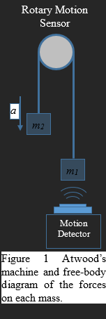
1. Figure 1: Atwood’s Machine and Motion Detector

Part 1: Constant Mass Difference

We collected data from the LoggerLite program by adjusting the masses to m1 < m2 and performing 3 different experiments. Afterwards, we kept the difference between the masses constant and increased the masses equally and conducted 3 more experiments and collected the data.

Part 2: Constant Total Mass

In the second stage of the experiment, we determined the total mass so that m1 < m2, conducted 3 experiments and collected the data. Afterwards, we increased the difference between masses by keeping the total mass constant and conducted 3 more experiments. We averaged the acceleration values we obtained from the data we collected from the LoggerLite program.

Unlike the experiment we did in the last stage, we also conducted a Theoretical Experiment and recorded the percentage difference as the margin of error.

Fit Line

In our experiments, we have values that doesn’t match each other. Therefore, we have to use a model that approximately satisfies our preciseness. This model is called fit line. It is used to understand the correlation between variables.

There is one independent variable and one dependent variable in our Attwood Machine experiment. I have used ∆m/m_{total} as independent variable and accelerations as dependent variable. I have used Excel to constitute this graph.

First, I have entered all values to the table for motional accelerations and got this graph.

As you can see from the graph, y axis represents acceleration and x axis represents our independent variable. And the dotted line which goes through the middle of the dots represents the fit line.

I have applied the same process to get the correlation between rotational accelerations and our independent variable. So, I got this graph.

3. Calculations

Part 1

# | m₁ (g) | m₂ (g) | Δm (g) | a_{exp}(m / s²)  (rot mot sens) | a_{exp}(m / s²)  (mot sens) | a_{theo}(m / s²)
1 |  |  |  | -1.533 | 1.050 | 1.59
2 | 50.7 | 70.3 | 19.6 | -1.627 | 1.042 | 1.59
3 |  |  |  | -1.457 | 1.015 | 1.59
 |  |  | Mean | -1.539 | -1.035 | 1.59
4 |  |  |  | -1.971 | 1.336 | 1.90
5 | 40.7 | 60.3 | 19.6 | -1.965 | 1.376 | 1.90
6 |  |  |  | -1.983 | 1.248 | 1.90
 |  |  | Mean | -1.973 | 1.320 | 1.90
Table 1 : Constant Mass Difference

Table 2: Constant Mass Difference Errors
M₁ | M₂ | a_{exp}  ₍m/s2)  (rot mot sen) | % error of a rotary motion theoretical | a_{theo} (m/s²)  motion detector | % error of a motion detector theoretical | % error of a between sensors
50.7 | 70.3 | -1.539 | %33 | 1.035 | 34.905 | %71
40.7 | 60.3 | -1.973 | %30 | 1.32 | 30.526 | %72

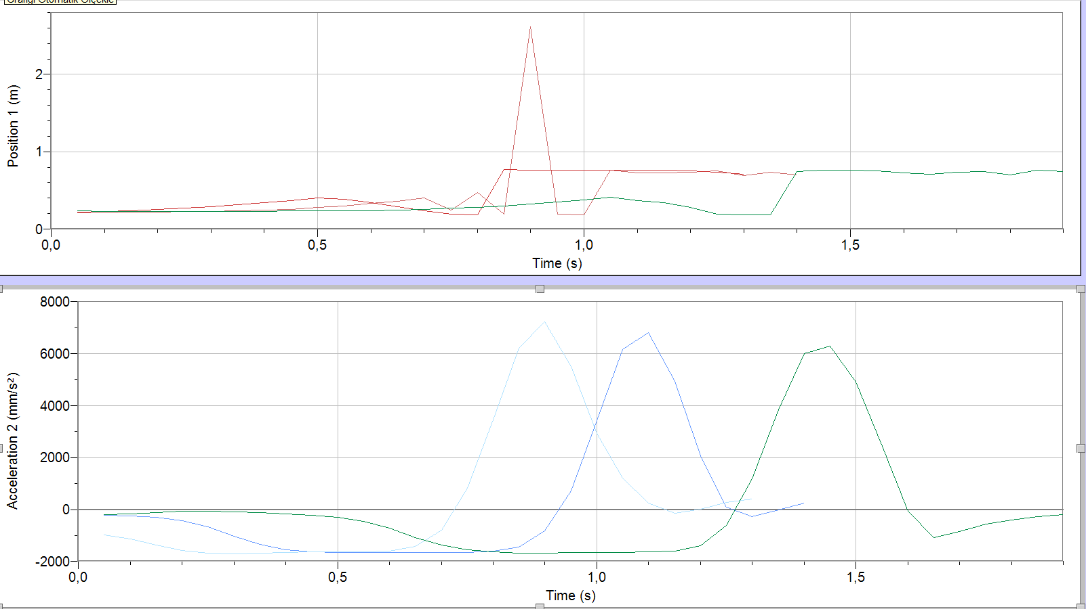
Graphs 1-2 : Position – Time and Acceleration – Time Graphs of Runs 1,2,3

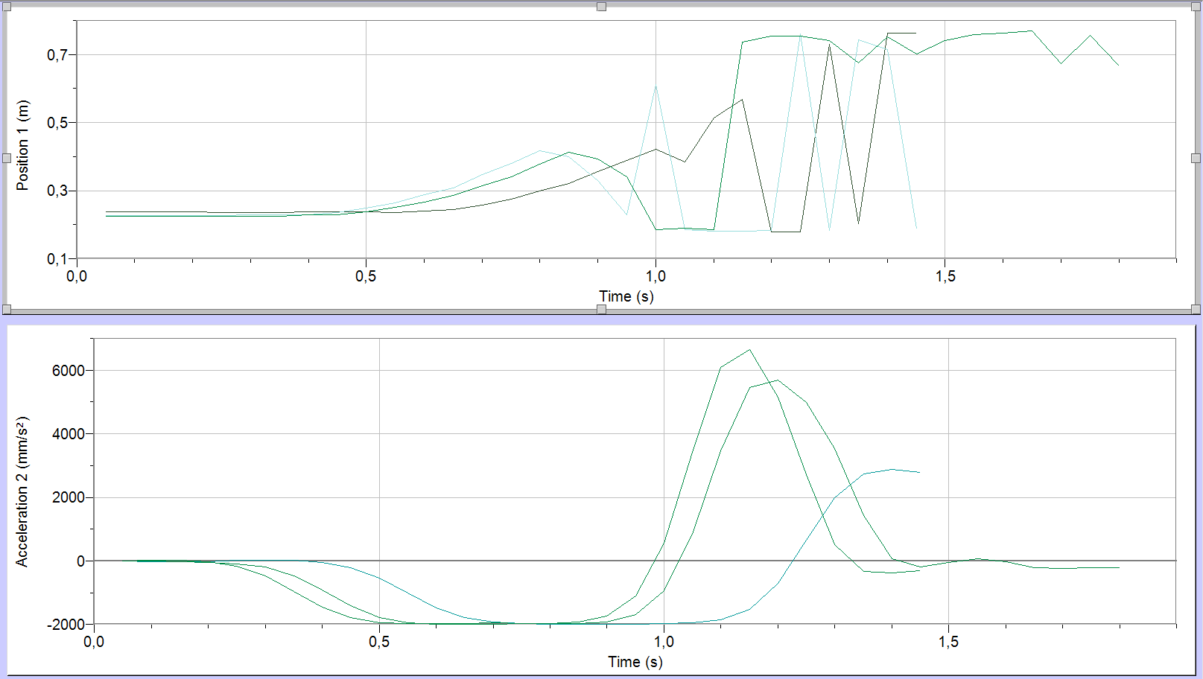
Graphs 3-4 : Position – Time and Acceleration – Time Graphs of Runs 4,5,6

Part 2

Table 3 : Constant Total Mass
# | m₁ (g) | m₂ (g) | m₂ (g) | a_{exp}(m / s²)  (rot mot sens) | a_{exp}(m / s²)  (mot sens) | a_{theo}(m / s²)
1 |  |  |  | -2.435 | 1.245 | 2.37
2 | 30.7 | 50.3 | 81 | -2.501 | 1.046 | 2.37
3 |  |  |  | -2.410 | 0.925 | 2.37
 |  |  | Mean | -2.448 | 1.072 | 2.37
4 |  |  |  | -4.790 | 3.102 | 4.79
5 | 20.7 | 60.3 | 81 | -3.894 | 2.519 | 4.79
6 |  |  |  | -4.334 | 3.142 | 4.79
 |  |  | Mean | -4.339 | 2.921 | 4.79
M₁ | M₂ | a_{exp}  ₍m/s2)  (rot mot sen) | % error of a rotary motion theoretical | a_{theo} (m/s²)  motion detector | % error of a motion detector theoretical | % error of a between sensors
30,7 | 50,3 | -2,448 | %55 | 1,072 | 54,767 | %81
20,7 | 60,3 | -4,339 | %40 | 2,587 | 39,018 | %72

Table 4: Constant Total Mass Errors

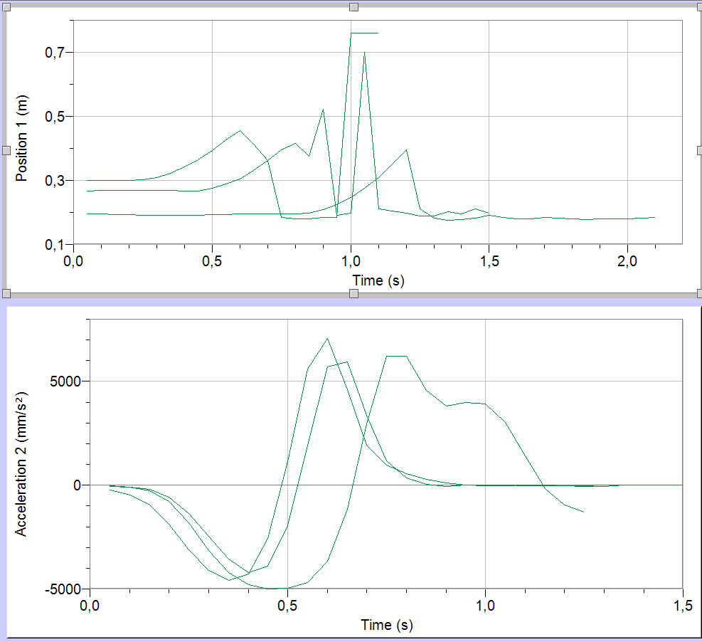
Graphs 5-6 : Position – Time and Acceleration – Time Graphs of Runs 7,8,9

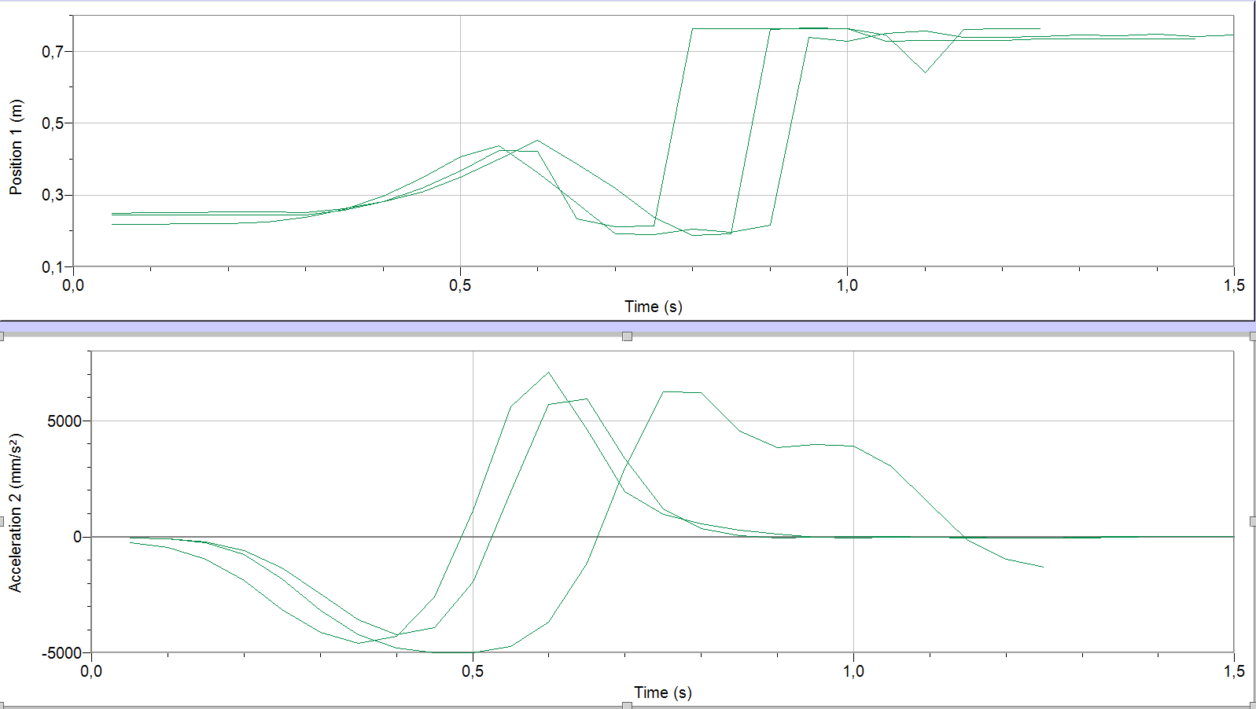
Graphs 7-8 : Position – Time and Acceleration – Time Graphs of Runs 10,11,12
Related Equations:
F_{net} = (m₁ - m₂) * g
m_{total} = m₁ + m₂
F_{net} = m_{total} * a
a = F_{net} / m_{total}
a = (m₁ - m₂) * g / (m₁ + m₂)

Calculations:
(70.3 – 50.7) * 9.8 / (70.3 + 50.7) = 1.59
(60.3 – 40.7) * 9.8 / (60.3 + 40.7) = 1.90
(50.3 – 30.7) * 9.8 / (50.3 + 30.7) = 2.37
(60.3 – 20.7) * 9.8 / (60.3 + 20.7) = 4.79

4. Conclusion

To conclude, we observed the change in accelerations using the difference between masses. Adhering to Newton's 2nd law, we compared the difference between a theoretical experiment and a practical experiment and found the margin of error. We graphically expressed the acceleration values occurred in the experiment using the LoggerLite program.

5. References

- Physics 1103.17 2 Report Guideline
- https://canvas.instructure.com/files/278105698/download?download_frd=1

- Physics 1103.17 Sample Report
- https://canvas.instructure.com/files/274698291/download?download_frd=1

6.Appendix




